**What** is the problem, **Why** that is a problem, **How** are your planning on solving, or **How** you solved it.

Due Sunday 10/31/2021

Class Week 11

Journal #4

Recounting:

We were able to get it working by connecting it together and using the basic libraries that will let us view the outputs of the sensors (magnetometer and time of flight) to let us get familiar with the sensors. We also noticed that particular magnetometer sensor package actually comes with an accelerometer and gyroscope. We talked about incorporating the accelerometer, but decided against it using it, because while it may be a nice added feature, it may actually cause false positives, like earthquakes and nearby vibrations from cars parking next to the intended spot. Aside from that, we were able to at least get the time of flight sensor to send a true statement to ChirpStack with Phong’s help. With his continuing help on the programming the sensor package, we should be able to get both sensors working and creating a boolean equation to send a true statement.

Current Problem:

We still need to program it to use both sensors and start thinking about packaging into a case so we can test it under cars and see what our range of values we need to look for. There is also the issue of calibrating the time of flight sensor based off the window used (plastic or glass with an airgap less than 0.5 mm)

Solution:

We just purchased a casing to package everything in, so we’re waiting on that. When we get a chance to group up again, we’ll tackle the coding to get both sensors working, talk about the boolean logic needed, and attempt to output a true statement with both sensors running (since we only got the initial true statement with only 1 sensor connected).

Block Diagram

(Open Parking spot taken)

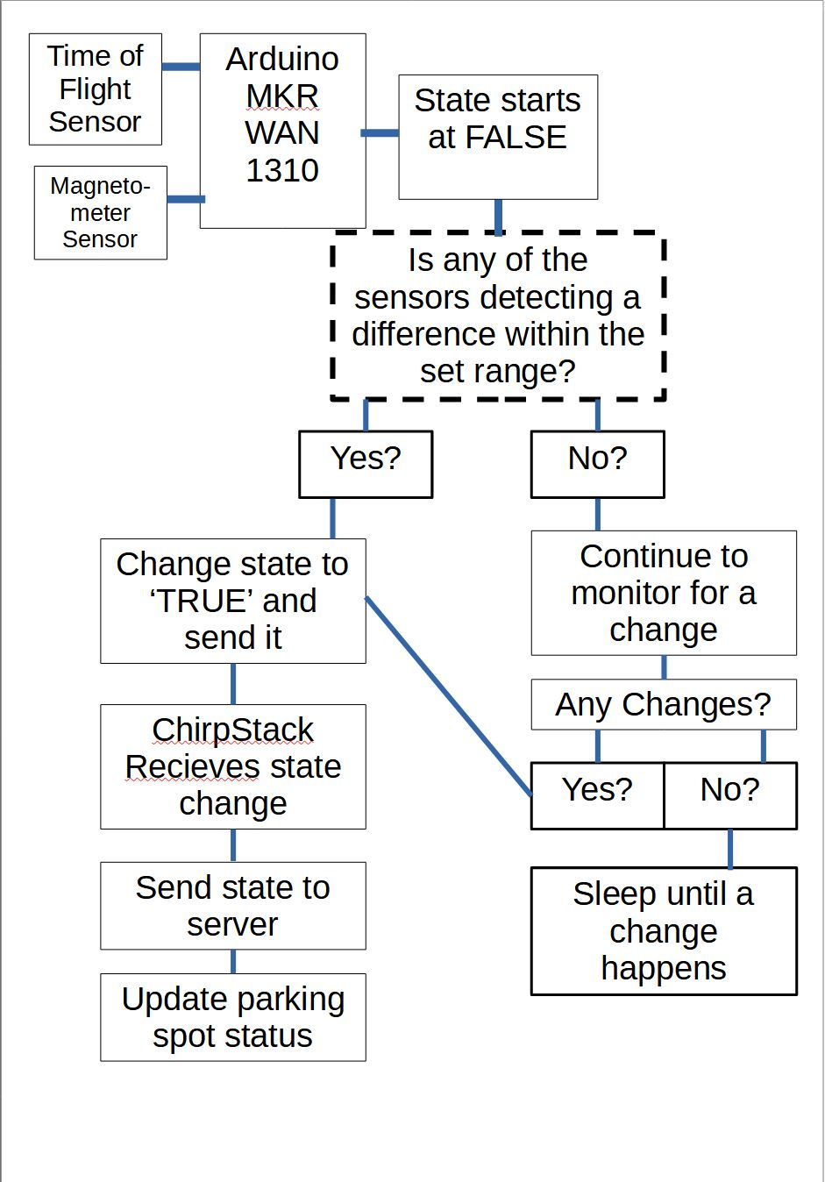

Block Diagram

(Someone Leaving the Parking Spot)

